Front of Shirt  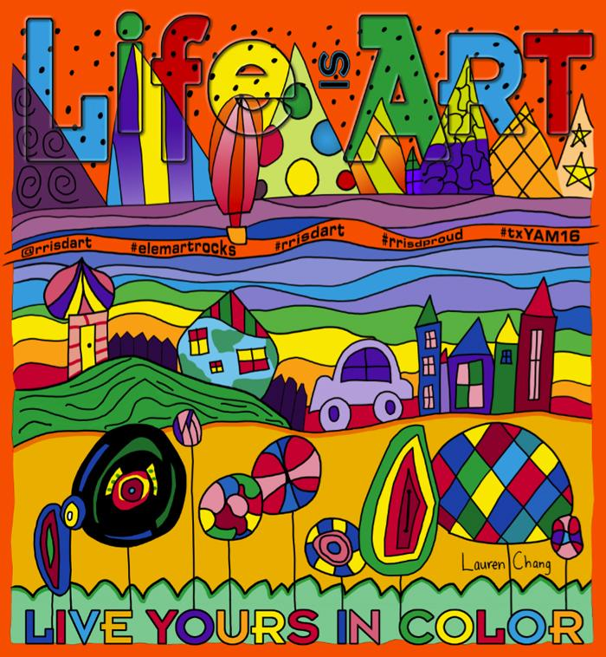  Back of Shirt | March is National Youth Art Month and the State of Texas has been a leader in Youth Art Month since the observance began in 1961. To celebrate this very special month, Round Rock ISD Visual Art sponsors a t-shirt design to celebrate the incredible work created by our students. 2016 is the 21st year of RRISD Youth Art Month t-shirts!  Be part of the celebration by ordering shirts from your campus art teacher. All proceeds from the sale of these items benefit your campus art program! Questions? Call your teacher Rebecca Story at 512-428-3037 or email Rebecca_Story@roundrockisd.org.

Student Name: _______________________________________________
Homeroom Teacher: _________________________ Grade: ___________

Number of
items ordered
Youth Small: |  | X $10.00 =
Youth Medium: |  | X $10.00 =
Youth Large: |  | X $10.00 =
Adult Small: |  | X $10.00 =
Adult Medium: |  | X $10.00 =
Adult Large: |  | X $10.00 =
Adult XL: |  | X $10.00 =
Adult XXL: |  | X $12.00 =
Adult XXXL: |  | X $12.00 =
Adult XXXXL: |  | X $12.00 =
 |  | TOTAL

Make checks payable to: Brushy Creek Elementary

All orders due by February 19, 2016 at the end of the school day!

